The New T41 V12.8 Boards.
What’s new… and why the change from V12.7?
April 25, 2026

We got a lot of feedback from people building the V12.6 and V12.7 RF board that it was very difficult to mount the PE4212 attenuators (one for receive and one for transmit) on the board due to the small part size (QFN part) and need for hot air solder tools to adequately solder the parts. In addition, we realized that the existing Si4241 clock wouldn’t allow for an auto-calibrate cycle where the receiver and transmitter (on the RF board) were both active at the same time (when the calibration cycle can be completely automated). To address these issues… essentially make the T41 V12 radio better, we decided to: 1) move these parts these parts to DIP-sized daughter boards that could be (sold) pre-made and easily added by the builder by adding IDC pins, and, 2) change to the si5351A-B-GM that has EIGHT separate oscillator outputs…. enough to generate a clock quadrature pair for the receiver, a pair for the transmitter, and one for CW (with three to spare!). That allows the receiver and the transmitter to be on simultaneously, and the calibration process to be automated. Simply solder some IDC pins on these small daughter boards… solder IDC sockets to the V12.8 RF board, and plug in the daughter cards.
This approach also allows some additional experimentation with the attenuators and oscillator. We’ve already designed a new twin attenuator board that has two PE4312 chips on it in series that gives a total of 63.5 db of attenuation in 1 db steps instead of the original 31.5 db in 0.5 db steps. This is nice for building an automatic hardware AGC for receive, and for having range in the output power control on transmit. A replacement for the oscillator board could be made using a high precision oscillator like the si5340 that is capable of a much greater frequency range, and more precise native quadrature generation. I suspect we will see some additional creativity as time goes on.
There is one additional change that was made to the LPF in order to use the new automatic antenna tuner. The TR carrier board was modified to be able to insert the tuner into the RF chain after before the TR switch. That allows the tuner to be in the RF chain BEFORE the switches for the one-of-four antenna selection.
These are the only changes made to date to the V12.7 boards to create a V12.8 set. The rest of the boards in a V12.7 or V12.8 set are really V12.6 boards. In any case, use the latest board versions for your new radio builds.
Pictures are priceless. The Figure below is a picture of a completed V12.6 board.

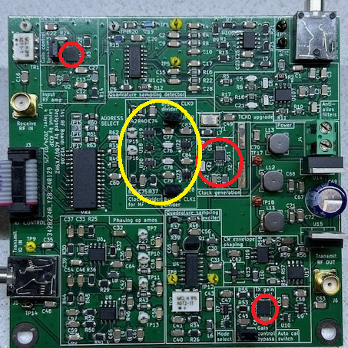

The two PE2312 attenuators and the si5351 oscillator are shown inside the red circles on the board. The MF circuitry in the yellow circle was also removed from the new V12.8 board because we were able to do this in software and simplify the hardware.

The new V12.8 board looks like this (module locations in red circles):
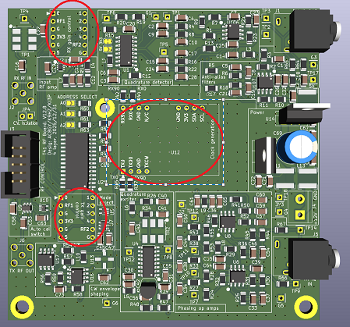

The picture clearly shows the main spot where the main oscillator daughter board goes in the center of the board, and the two places where the attenuator modules go. The new pre-made modules to go into those spaces and look like this:

Single attenuator module: AND/OR The dual attenuator module:

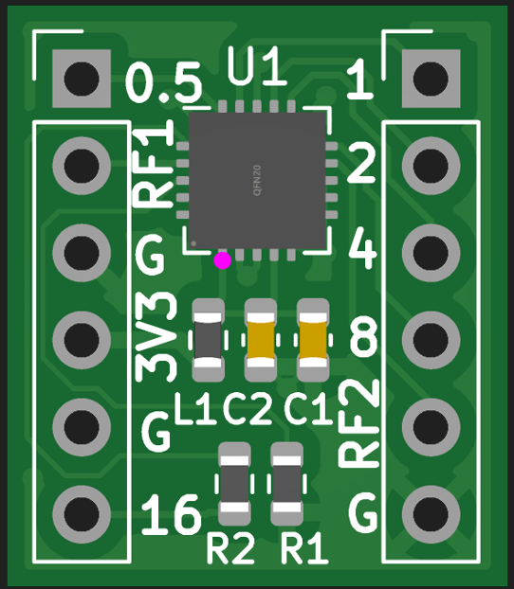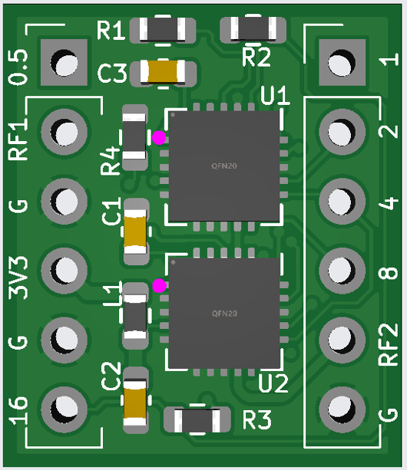

And the 8-output si5351 oscillator daughter card (not populated):

